ActiveNet JIRA Process

Contents

JIRA Project URL 3

Issue Types 3

Issue Status (New Feature/Bug) 4

Product 4

Development 4

QA 4

Document 4

Process Flow 5

New Feature 5

Bug Bug Sub-Task 5

Escalated Support Issue 6

Time Tracking 7

Time Tracking Fields 7

Time Tracking Rules 8

Code Review 8

Team Code Review 8

Peer Code Review 8

Revision History

|  |  |  |
| --- | --- | --- |
| Date | Author | Content |
| 07/15/2014 | Leon Chen | Initial. |
| 07/29/2014 | Leon Chen | Modified flow for code review. |
| 08/07/2015 | Leon Chen | Up to date based on latest JIRA changes. |

# JIRA Project URL

* <http://jira.active.com/jira/browse/ANE>

# Issue Types

* Standard Type
  + **Epic**
    - A collection of new features & bugs.
  + **New Feature**
    - A new feature of the product, which has yet to be developed.
  + **Bug**
    - A post-release problem which impairs or prevents the functions of the products.
  + **Escalated Support Issue**
    - Issue escalated from support for attention by development.
  + Feature Request
  + Simple Task
* Sub-Task Type
  + **Sub-task - Bug PreRelease (Not used anymore)**
  + **Bug Sub-Task**
    - Program defects against New Feature/Bug found by QA during functional testing before release.
  + **DEV Subtask**
    - Sub tasks used by development to break down a standard issue. Include “Coding”, “Research”, “Code Review” etc.
  + QA Subtask
  + BA Sub-Task
  + Subtask - Automated Tests

(* **This** is used by DEV team)

# Issue Status (New Feature/Bug)

## Product

* OPEN
* DESIGN
* PRODUCT OWNER REVIEW
  + BA to review if a New Feature is implemented as expectation.

## Development

* **IMPLEMENTATION**
  + Issue in implementation.
* **CODE REVIEW**
  + DEV team internal peer code review.

## QA

* TESTING

## Document

* DOCUMENTATION
* CLOSED

(* **This** is participated by DEV team)

# Resolution

* Completed
  + Used for ER/Simple Task/DEV Subtask to identify a task is completed
* Fixed
  + Only use for a bug when it’s really code fixed.
* Won’t fix
  + The problem described is an issue which DEV/QA/BA agreed that don’t need to be fixed.
* Duplicate
  + The problem is a duplicate of an existing issue. (Please link it to the duplicate one)
* Cannot Reproduce
  + All attempts at reproducing this issue failed, or not enough information was available to reproduce the issue. Reading the code produces no clues as to why this behavior would occur. If more information appears later, please reopen the issue.
* Not a Bug
  + The root cause of the problem is not a software issue that can be fixed.
* Environment Issue
  + The problem is caused by environment
* User Error
  + It’s not a bug. User’s incorrect behavior, understanding or setting resulted it
* Third Party
  + The issue is caused by 3rd party for example AMS, AS, GA that cannot be fixed from our side
* By Design
  + There is specific design required this behavior.

# Defect Origin

* Coding Error
* Coding Missed Implementation
* Implementation Missed Requirements
* Requirements Ambiguous
* Requirements Late Change
* Requirements Missing
* UX Design Ambiguous
* UX Design Late Change
* UX Design Missing
* N/A – Not a Bug

# Process Flow

## New Feature

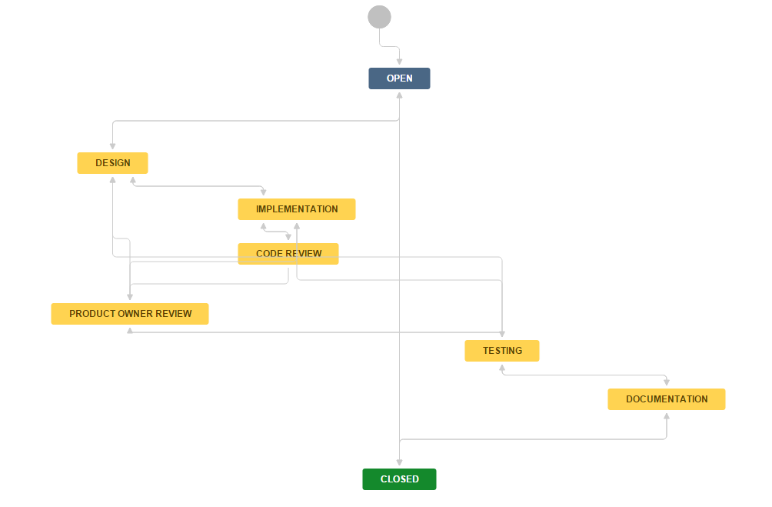

## Bug Bug Sub-Task

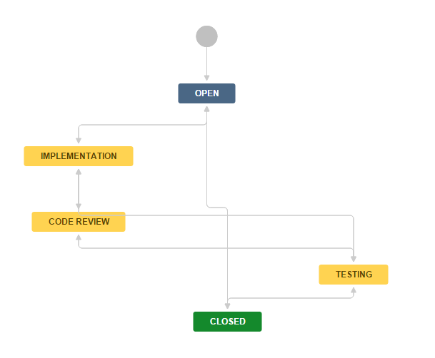

## Escalated Support Issue

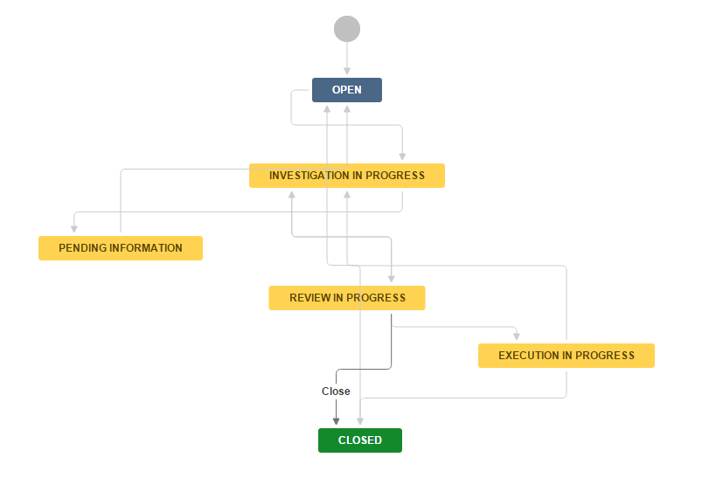

# Time Tracking

JIRA Time Tracking system is used to track the estimation, remaining and worked hours for each issue. From the time tracking we can get Sprint progress/risk by hour’s burn down chart and the individual/team work load.

## Time Tracking Fields

* Estimated
  + The original estimation (hours) for a task provided by DEV/QA during Sprint planning meeting.
  + Estimated should not be changed after the planning meeting.
* Remaining:
  + The hours remained to finish a task. It is updated by DEV/QA every day/once finishing a task.
  + Remaining is updated automatically (Estimated - Logged) or manually (estimation for the remaining from DEV/QA)
* Logged
  + The hours already spent on a task. It is updated by DEV/QA every day/once finishing a task.

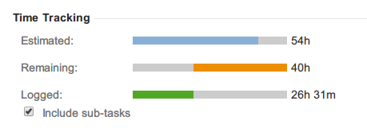

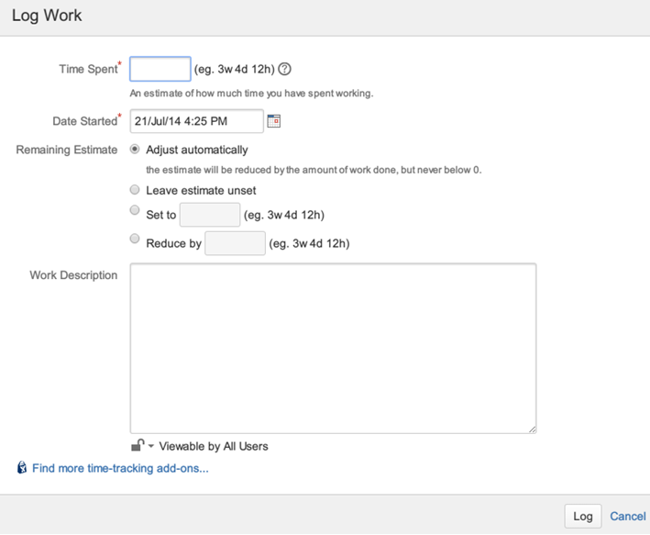

## Time Tracking Rules

1. All time tracking (Estimated, Remaining, and Logged) should be on Sub-Task issue types.
2. All tasks’ “Estimated” should be inputted to JIRA during the Sprint planning meeting before a Sprint official starts.
3. All tasks “Remaining” should be set to 0 when the task is sent to Documentation/Closed.
4. “Remaining” should not be 0 if a task is not completed so if a “Logged” is larger than “Estimated” in a real case the “Remaining” should be updated manually by a reasonable value.
5. Only estimate and log the task-related hours (research, coding, review, testing, and discussion etc). Regular meeting, communication should be excluded (already covered by Focus Factor).

# Code Review

## Team Code Review

Take place each day during the DEV team. Review together for each checked in codes on SVN on that day.

## Peer Code Review

* During Sprint Planning meeting, DEV team decides which New Feature/Bug needs peer code review and which doesn’t.
* A “Subtask – Implementation” as “DEV – Code Review” should be created with the other sub tasks (“DEV - Coding”, testing tasks…) with estimation/assignee during the Sprint Planning meeting.
* The reviewer should be the Module Owner in the other Scrum team or the senior/experienced developer in the team.
* Crucible is used for peer code review.